Big Mountain Resort is a ski resort located in Montana. Big Mountain offers spectacular views of Glacier National Park and Flathead National Forest, with access to 105 trails. The trails are serviced by 11 lifts, 2 T-bars, and 1 magic carpet for novice skiers. The longest run is named Hellfire and is 3.3 miles in length. The base elevation is 4,464 ft, and the summit is 6,817 ft with a vertical drop of 2,353 ft.

The resort has generally used a pricing strategy of charging a premium above the average price of resorts in its market segment. And while this strategy takes into consideration the current market, it leaves out of the question the value perception of all the features the hotel has to offer and how much more money would the customers be willing to pay for features like vertical drop, area covered by snow makers, the number of runs, the fast quads, the number of chairs or the skiable terrain, all of them features that Big Mountain exceeds compared to the market.

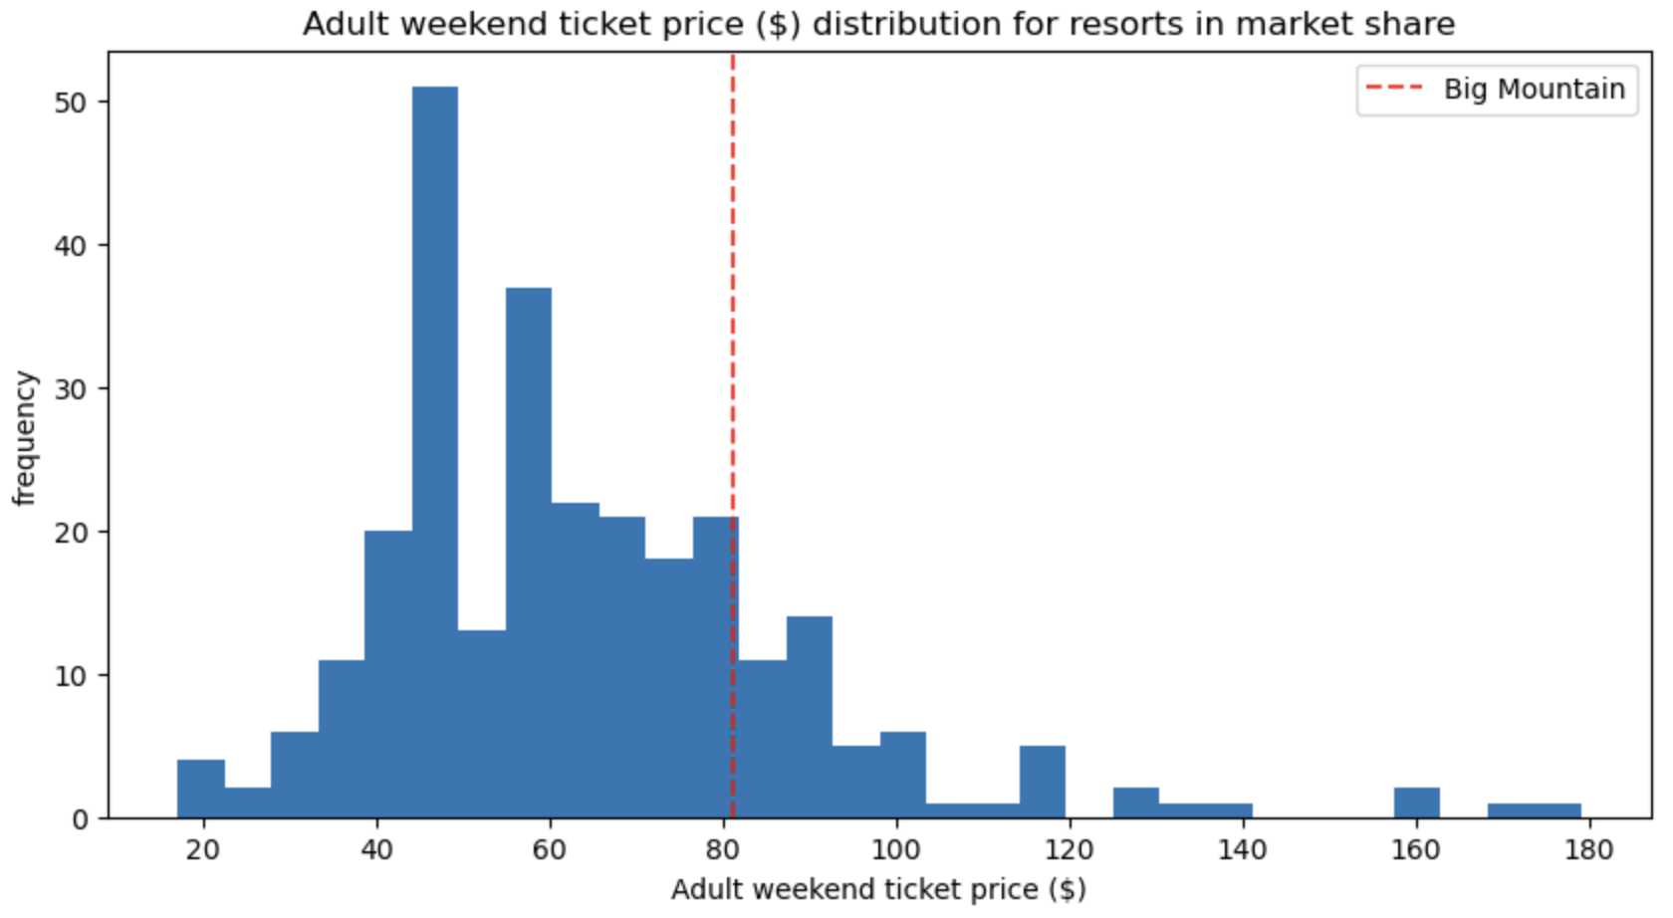

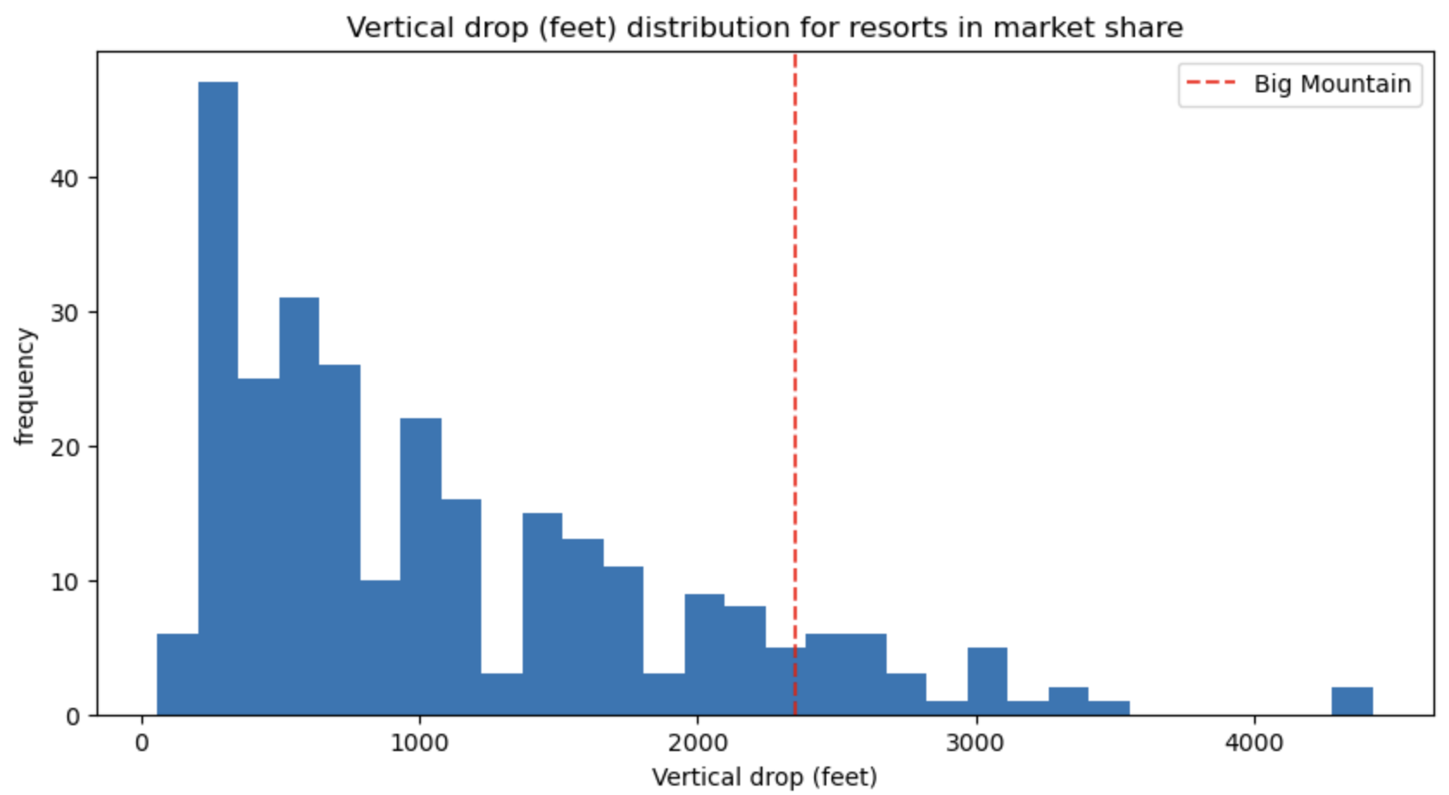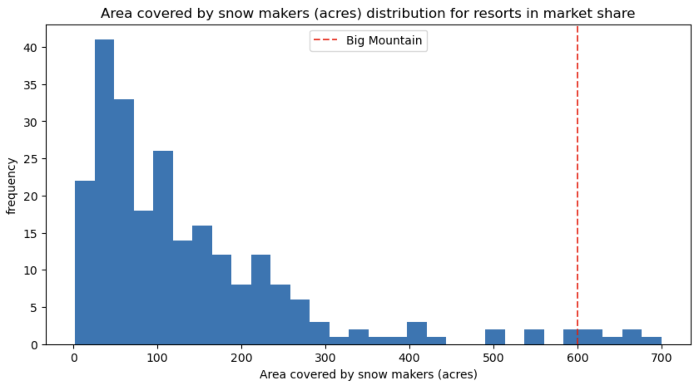

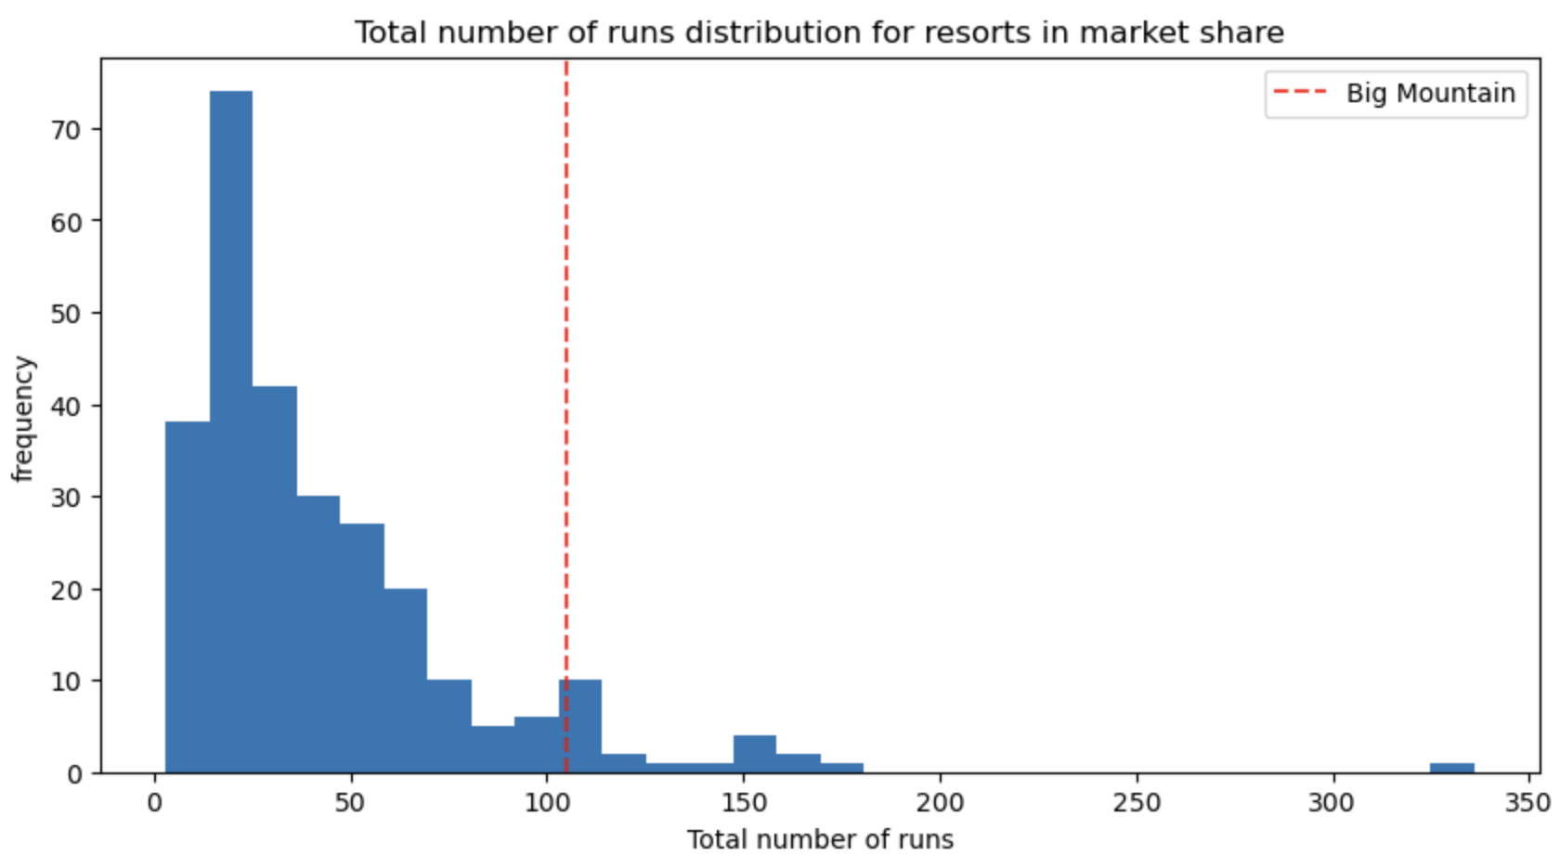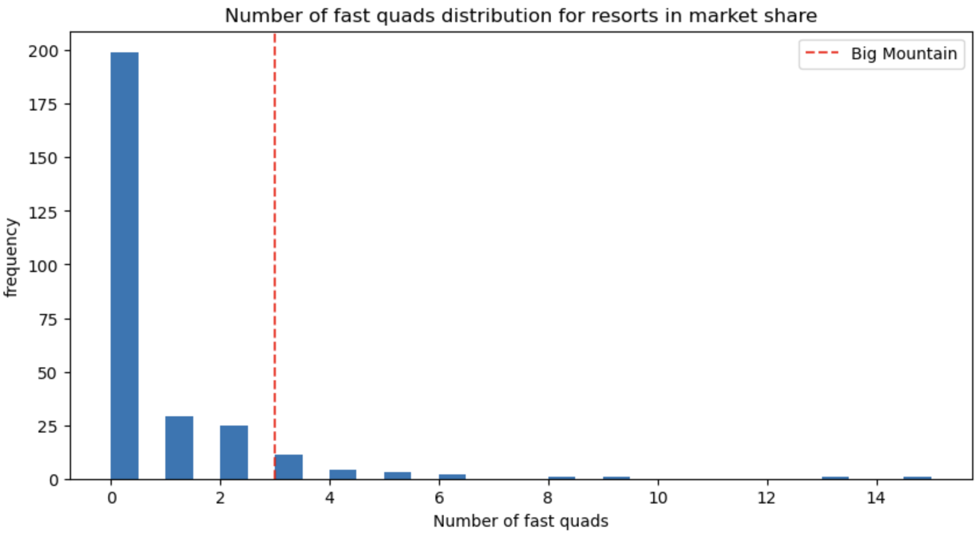

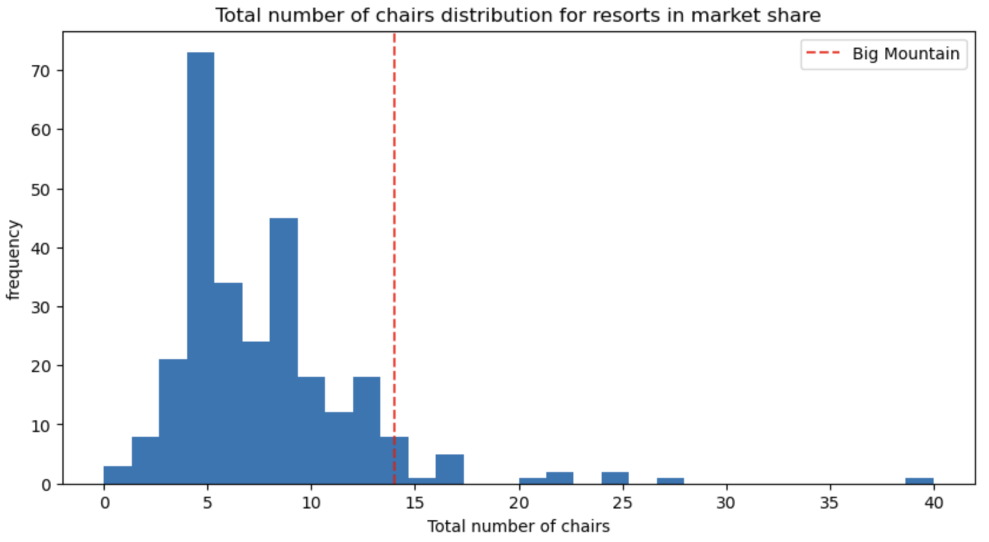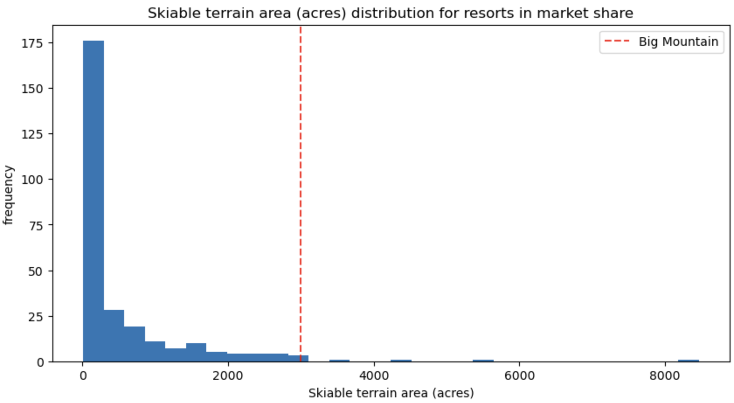

Looking at the graphs presented, we can see that in fact Big Mountain is positioned fairly high in price but when we look at the features of interest we can understand that Big Mountain Resort is in fact one of the top resorts offering some of the best features across the country. This means the customers are likely willing to pay a much higher premium based on what the resort has to offer.

In order to begin the analysis, we were provided with a list of 330 resorts with information like their region, state as well as features like the elevation, drop, area covered in snow and especially the price for weekend and weekday tickets. The first stage of data wrangling included a clean up around missing data, resulting in a removal of columns (fastEights and adultWeekday) due to the amounts of missing data, and several rows with data that were either missing or out of the ordinary. At the end of this stage, we ended up with 227 entries, with features that follow somewhat normal distributions with minimal missing or erroneous values.

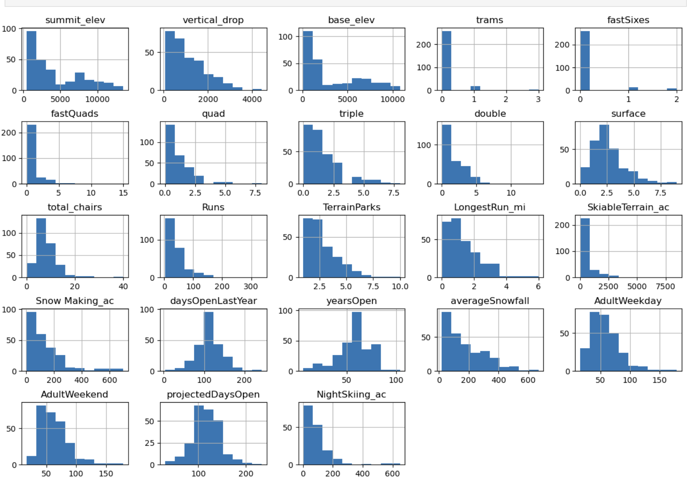

The major thing to call out here is that even though we removed adultWeekday, we are keeping and projecting the adultWeekend price. This decision was made based on the amount of missing data for the weekday price column.

The second stage of the data analysis included an analysis at State level. When analyzing the state information for all the features. We identified that there was no major difference in the distribution of features across states and we could treat all resorts as being part of the same bucket.

Once we were able to get rid of the state feature, we started the pre-processing and data training process. Our initial model of comparison was the average price for all existing data, and the metrics recommended for measure of quality were:

* R-squared
* Mean absolute error
* Mean squared error

During the model research stage, we compared our base model (average) with a linear regression and a random forest regressor. The resulting ideal model was a random forest regressor which provided the best metrics in comparison to the other 2 models.

The resulting model suggests a recommended price of $95.87 for the weekend ticket ($14.87 higher than the current price). Some of the main features supporting the price increase are:

* Number of Fast Quads
* Number of Runs
* Snow Making Acres
* Vertical drop

All of which, Big Mountain is way above average in comparison to the rest of the resorts in the country.

From this analysis, we recommend the executive team to implement the new pricing strategy and increase their ticket prices closer to the recommended $95.87. This would result in an increased revenue of over $5.2M without having to invest anything further.

It is important to call out that this model assumes the demand remains the same based on new prices. However, as we know based on supply/demand, there are probably a lot of customers currently taking advantage of the underpriced weekend tickets for Big Mountain and once these ticket prices are adjusted, it is normal to expect a dip in the demand. The next model I would recommend running would include the expected demand based on the features the resort can offer, so we can connect the increase in revenue per ticket with the actual changes in expected demand.